**Mapreduce program to remove commas present inside the double quotes**

**Driver class**

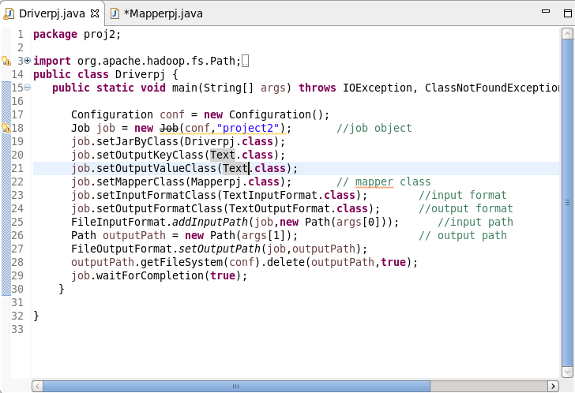

**Mapper Class**

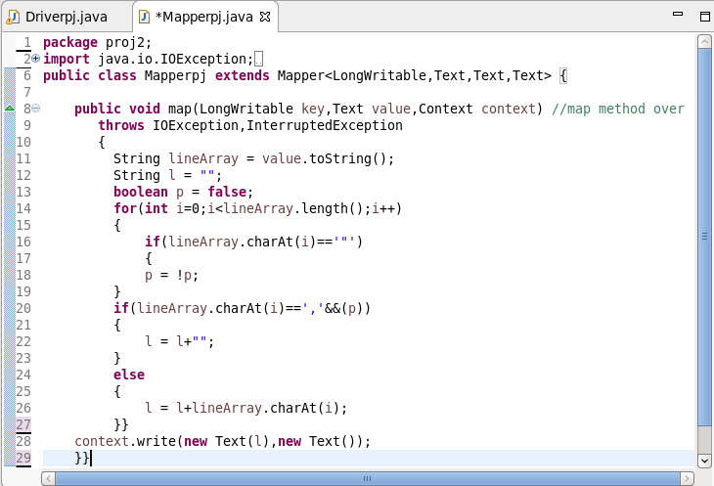

**jar file**

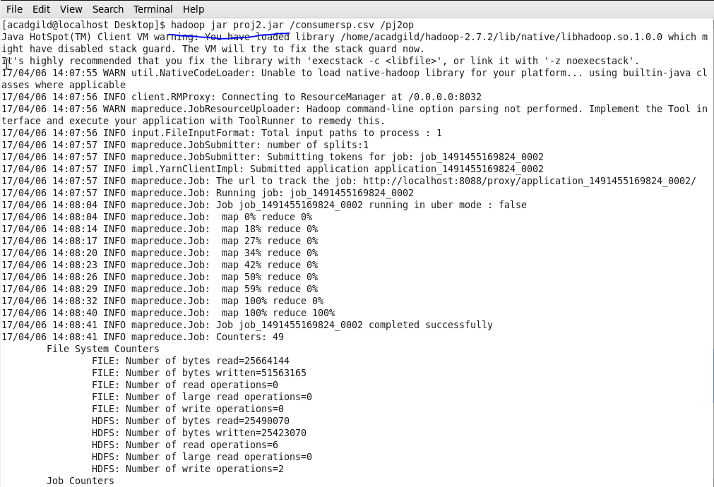

**Output**

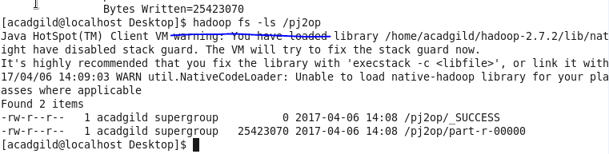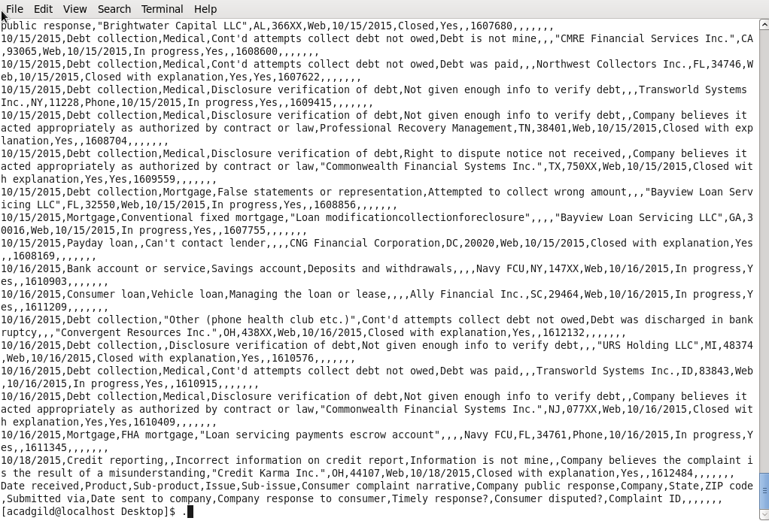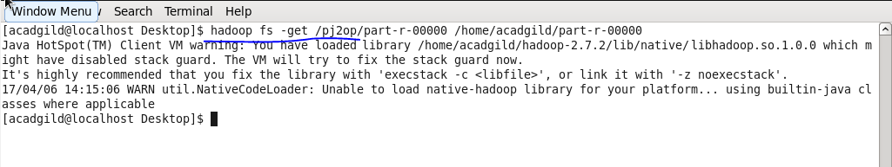

**pig script to find no of complaints which got timely response**

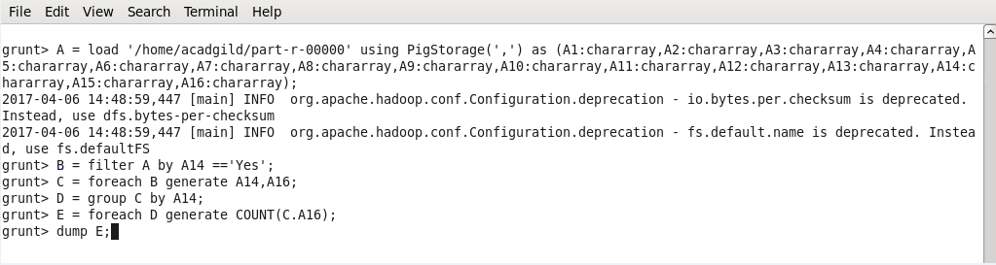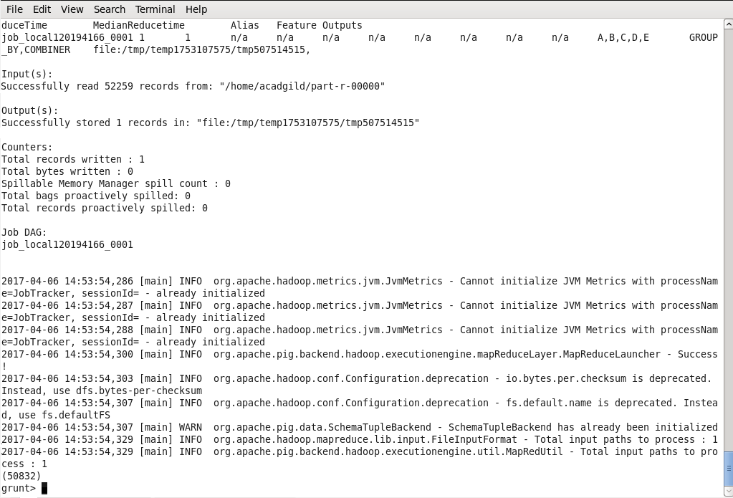

**pig script to find no of complaints where consumer forum forwarded the complaint same day they received to respective company.**

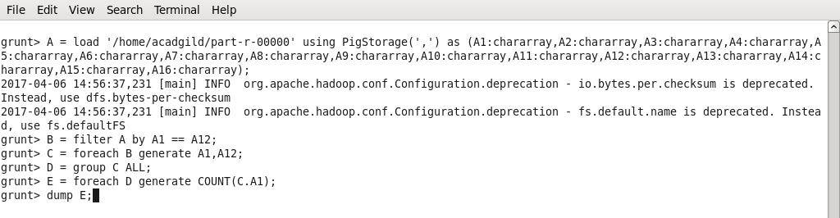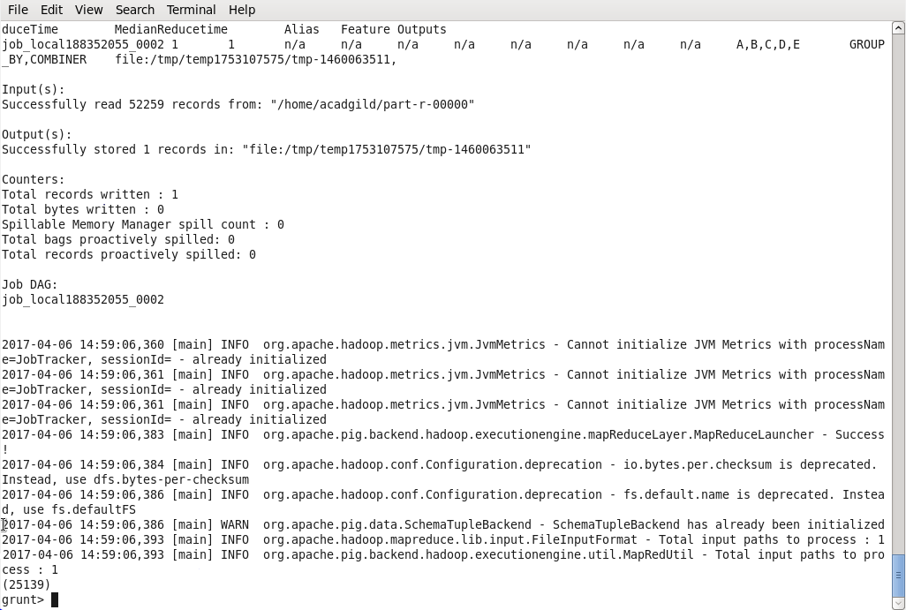

**pig script to find list of companies topping in complaint chart (companies with maximum number of complaints).**

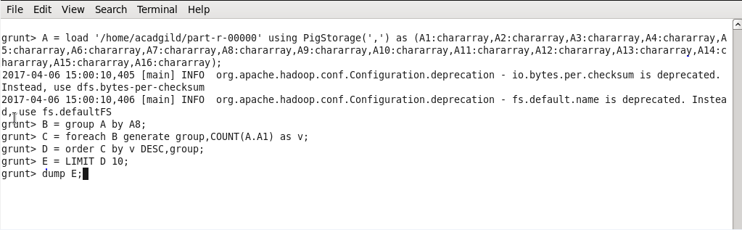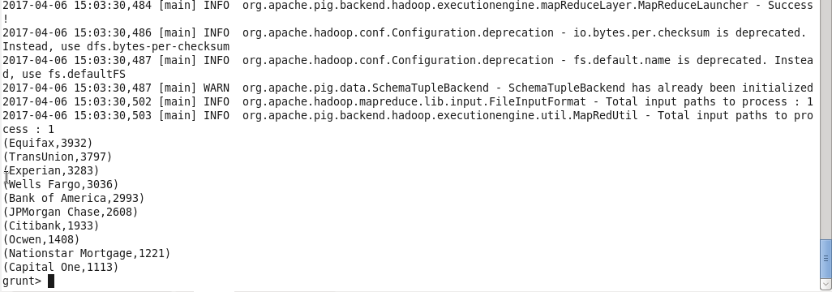

**pig script to find no of complaints filed with product type has "Debt collection" for the year 2015.**

